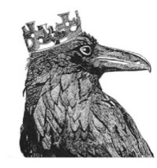
Perran-ar-worthal
Local History Group

Tues 18th March 2025
At the Perranwell Centre 7.30pm

‘The Bronze Age in the Carnon Valley’

Speaker: James Gossip field archaeologist with Cornwall Archaeology Unit.

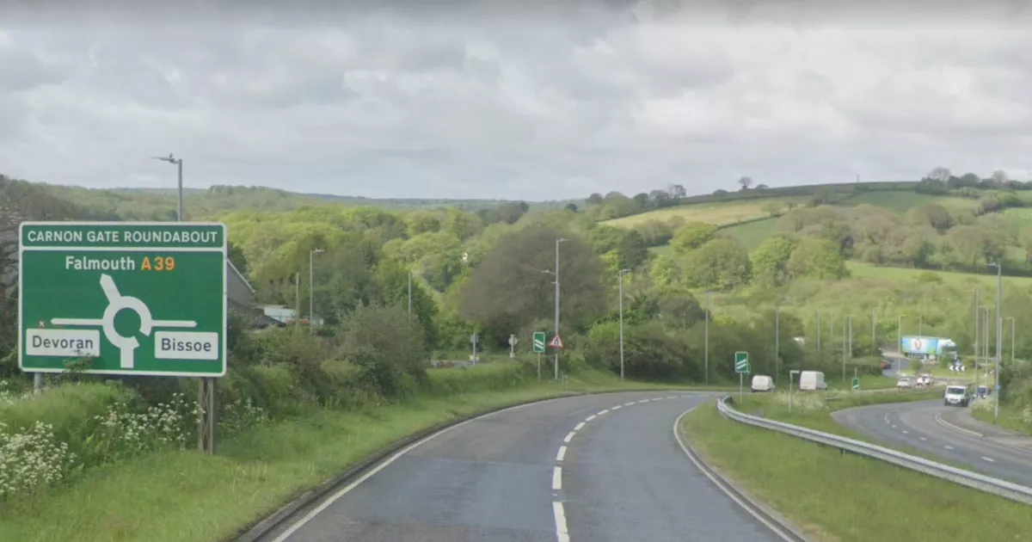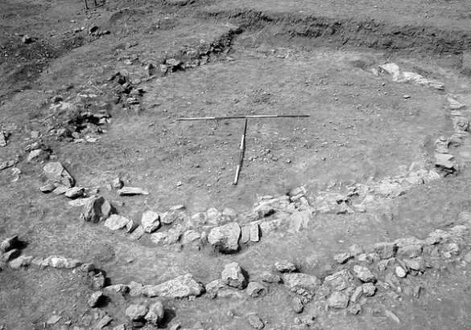

James excavated a Bronze Age roundhouse found during the construction of the Carnon Gate roundabout in 2008 which has been dated as being built between 3,300 and 3.500 years ago. He will tell us about this exciting find and his investigation into the evidence for the importance of Cornwall, and especially the Carnon River, in exporting tin across Europe in the early Bronze Age.

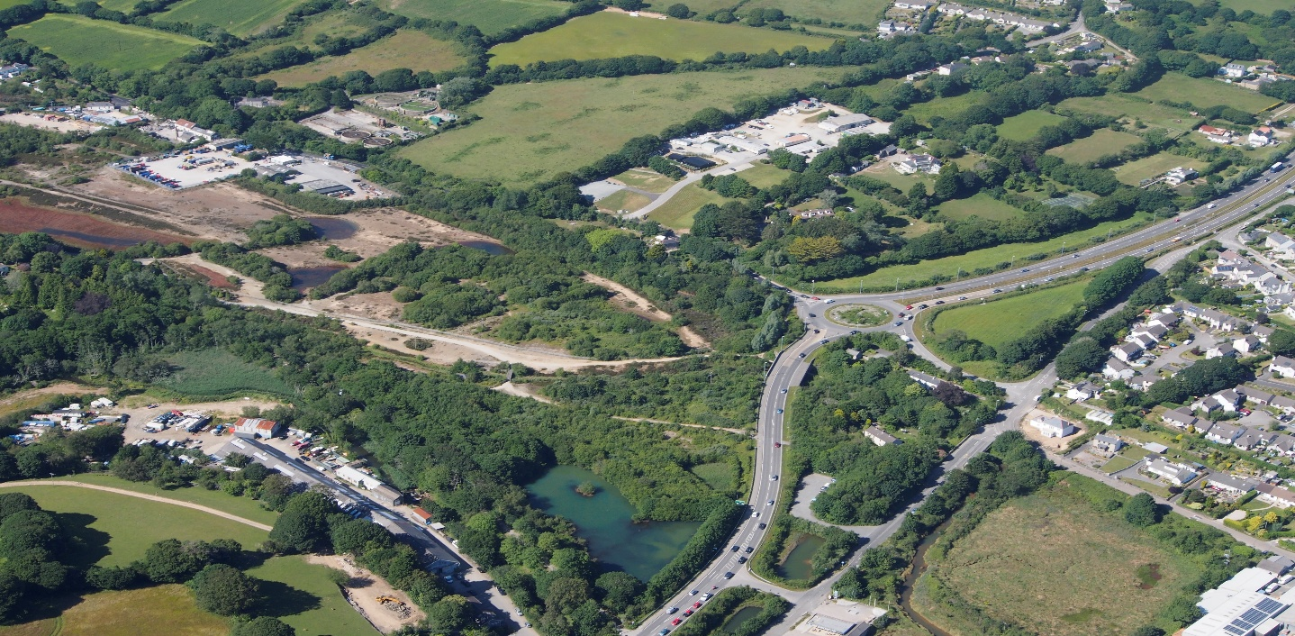

Do come along and join us to find out more.

Members £1 Non members £4 annual membership £6

